**Test Case Scenarios:**

|  |  |  |  |  |  |  |  |  |
| --- | --- | --- | --- | --- | --- | --- | --- | --- |
| Test Case | Project Name | Project Start Date | Task Name | Task Description | Duration (days) | Expected Start Date | Expected End Date | Notes |
| 1 | Project Demo 1 | 4/27/2020 | Task Demo 1 | No Dependents | 1 | 4/27/2020 | 4/27/2020 |  |
|  |  |  | Task Demo 2 | No Dependents | 2 | 4/28/2020 | 4/29/2020 |  |
|  |  |  | Task Demo 3 | Dependent of Task Demo 4 | 3 | 4/30/2020 | 5/2/2020 | Sub task of Task Demo 4 |
|  |  |  | Task Demo 4 | Depends on Task Demo 3 | 4 | 5/3/2020 | 5/6/2020 |  |
| 2 | Project Demo 2 | 4/15/2020 | Task Demo 1 | No Dependents | 1 | 4/26/2020 | 4/26/2020 | Sub task of Task Demo 7; not included in the project |
|  |  |  | Task Demo 3 | Dependent of Task Demo 4 | 3 | 4/27/2020 | 4/29/2020 | Sub task of Task Demo 4; not included in the project |
|  |  |  | Task Demo 4 | Depends on Task Demo 3 | 4 | 4/30/2020 | 5/3/2020 | Sub task of Task Demo 7; not included in the project |
|  |  |  | Task Demo 5 | Depends on Task Demo 6 | 5 | 4/21/2020 | 4/25/2020 |  |
|  |  |  | Task Demo 6 | Dependent of Task Demo 5 | 6 | 4/15/2020 | 4/20/2020 | Sub task of Task Demo 5 |
|  |  |  | Task Demo 7 | Depends on Task Demo 1 and Task Demo 4 | 7 | 5/4/2020 | 5/10/2020 |  |

**Test Case 1 Output:**

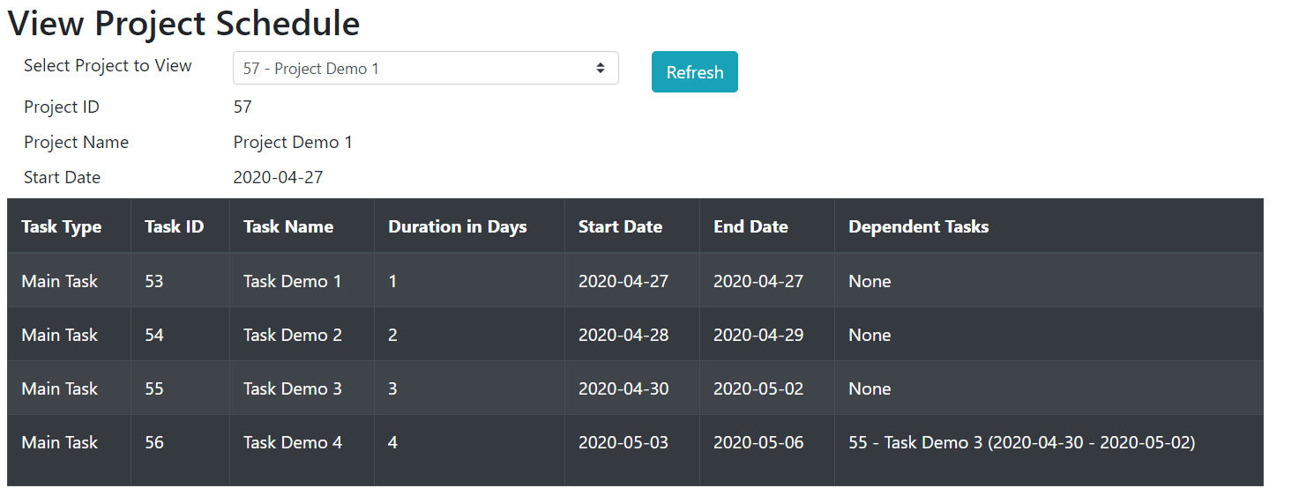

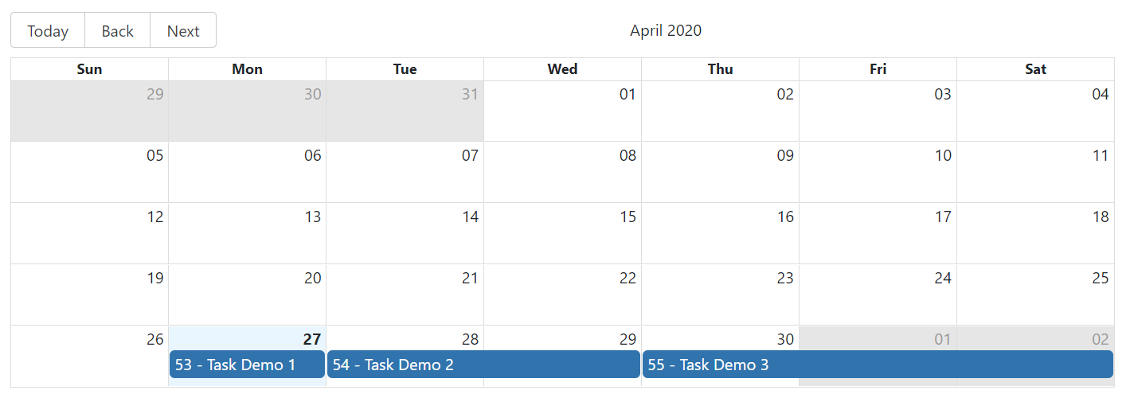

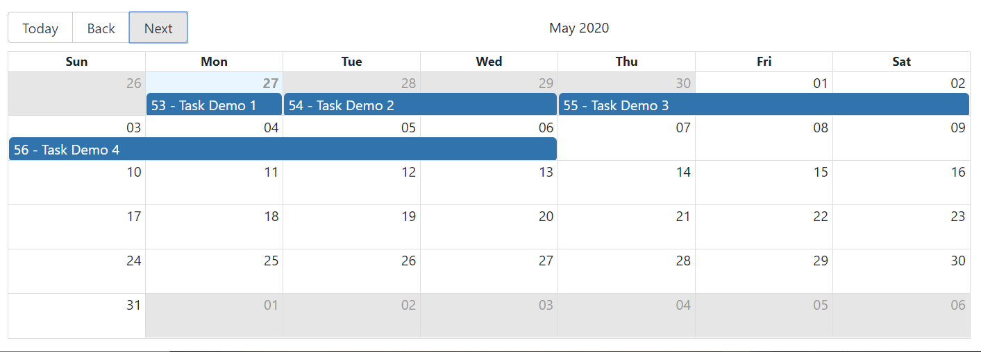

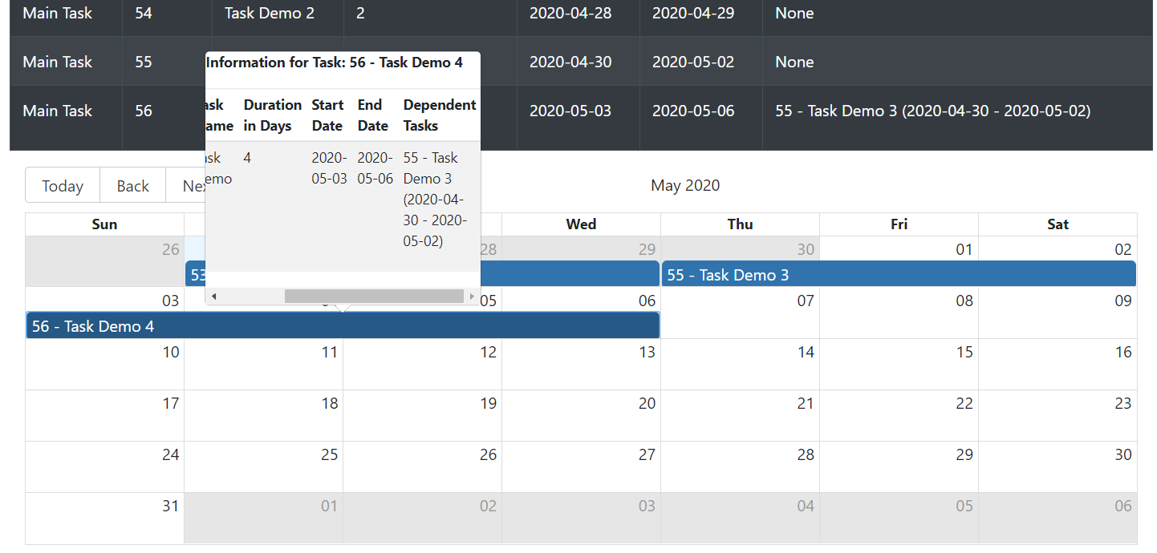

**Test Case 2 Output:**

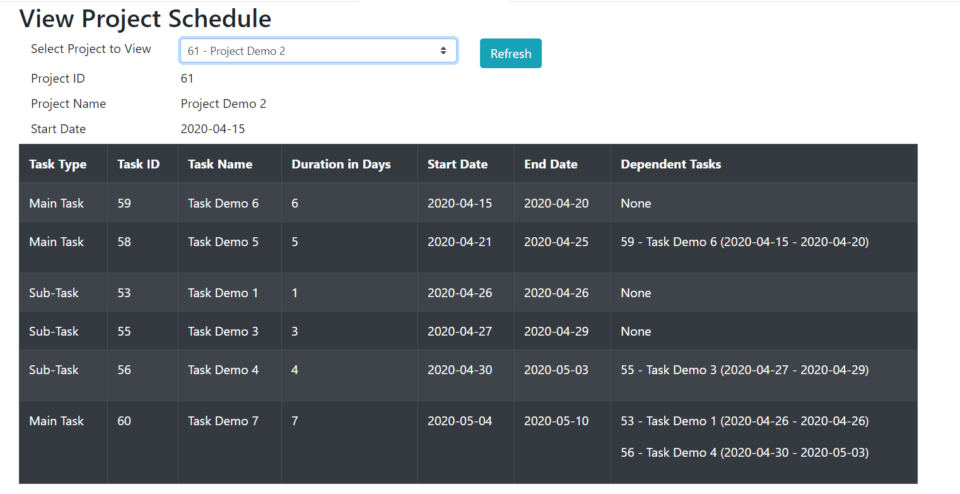

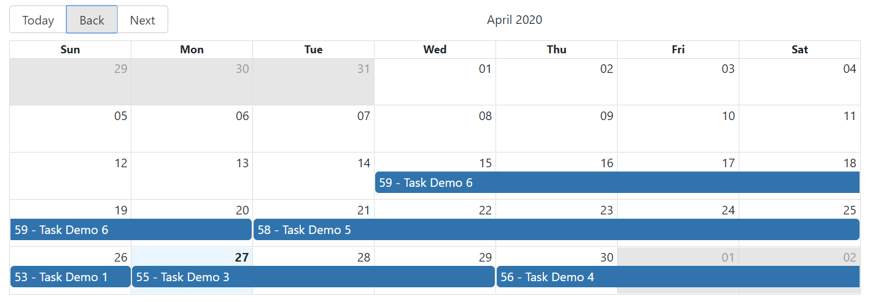

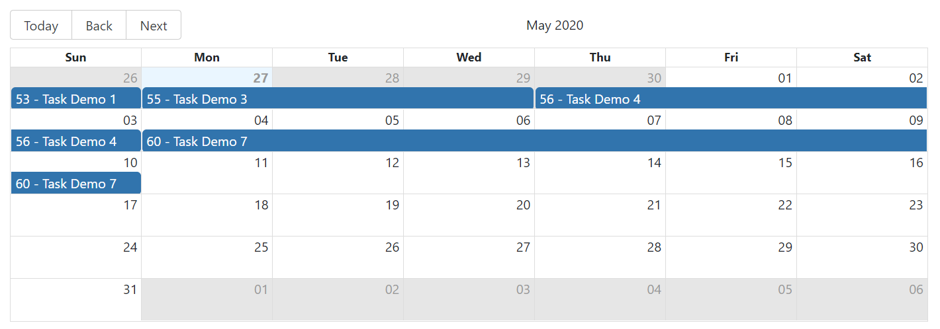

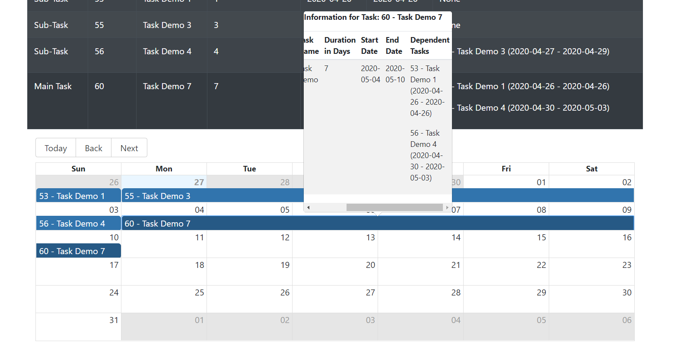

**Rest API for viewing ALL PROJECTS:**

<https://cd3236e9.ngrok.io/rest/scheduler/view/all>



**Rest API for viewing PER PROJECT:**

[https://cd3236e9.ngrok.io/rest/scheduler/view/{id}](https://cd3236e9.ngrok.io/rest/scheduler/view/%7bid%7d)

where {id} is the project id:

sample: <https://cd3236e9.ngrok.io/rest/scheduler/view/57>



(To view all REST APIS available in the project, please see Project Scheduler User Manual document).

**You can play around on the project scheduler application: https://jeremypunsalaniscalevlocity.github.io/project-scheduler-app/**